Project -1 : Application Deployment
Clone repository:
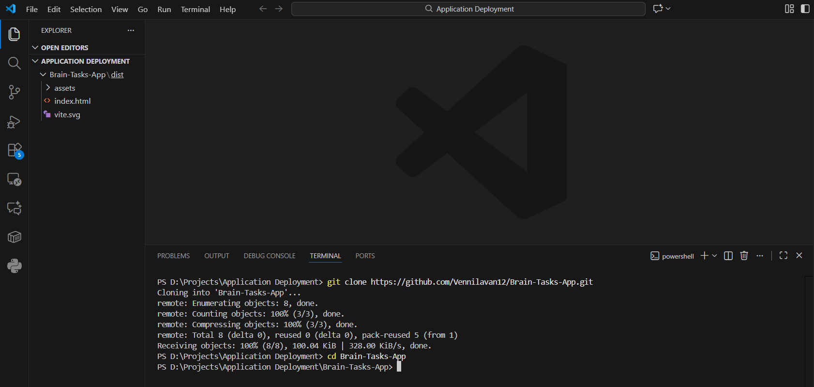

Dockerize the application
Create a file Dockerfile in repo root:
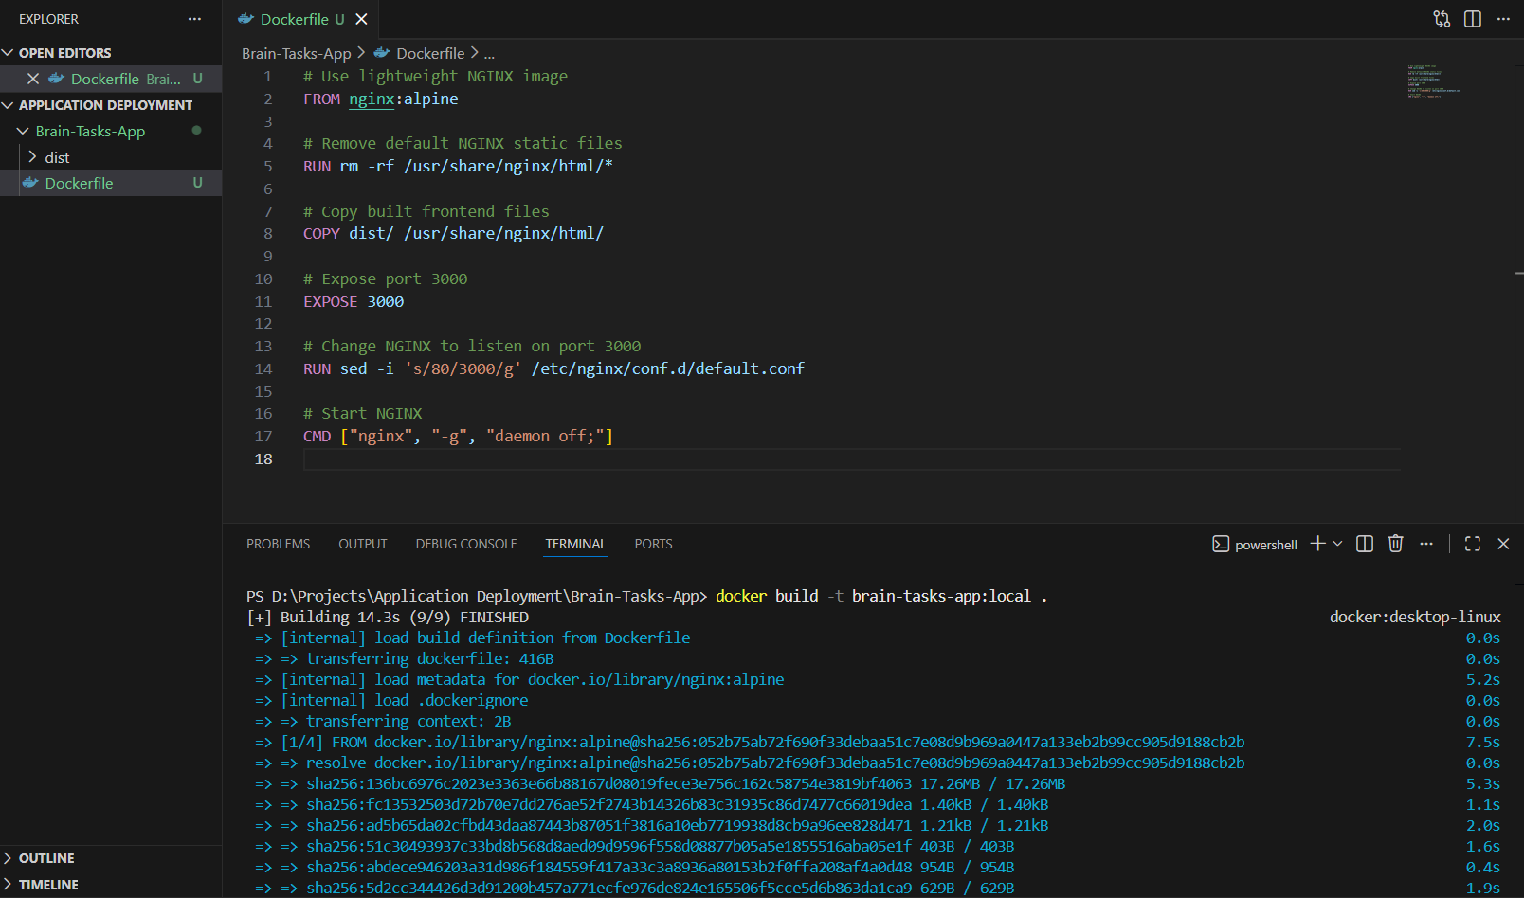
Docker build & run
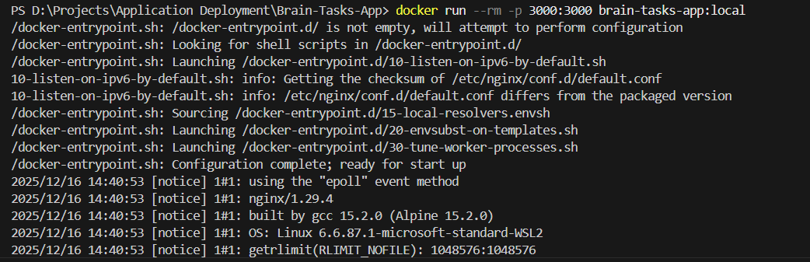

Docker Desktop Local:
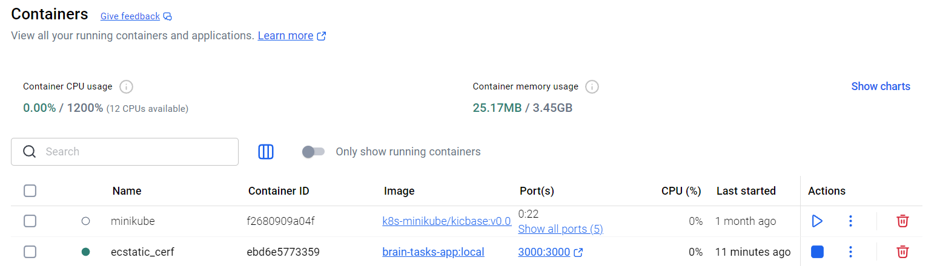

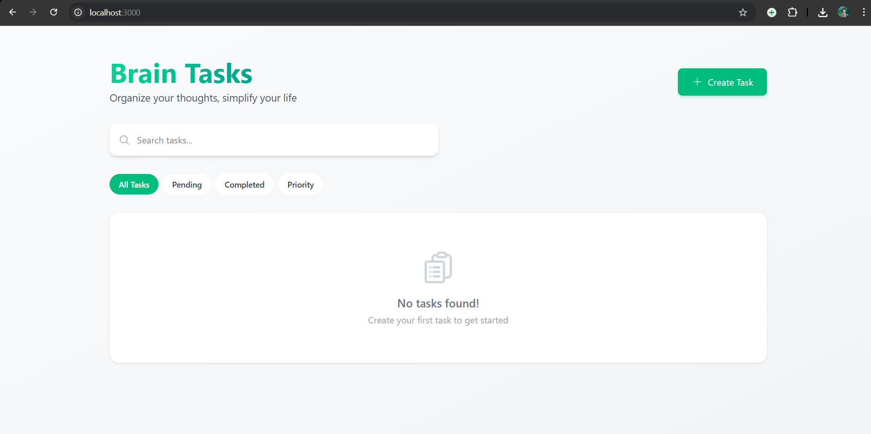

Create ECR Repository
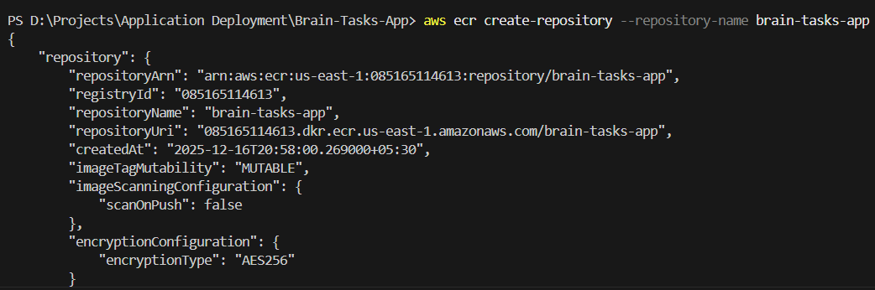
Authenticate and tag
Push
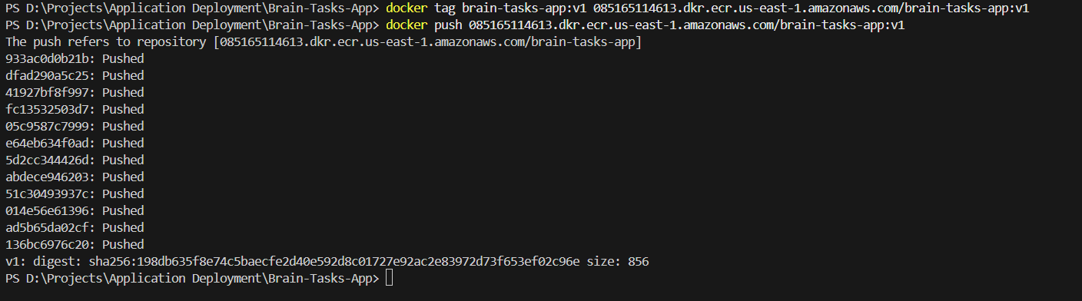

ECR Repository
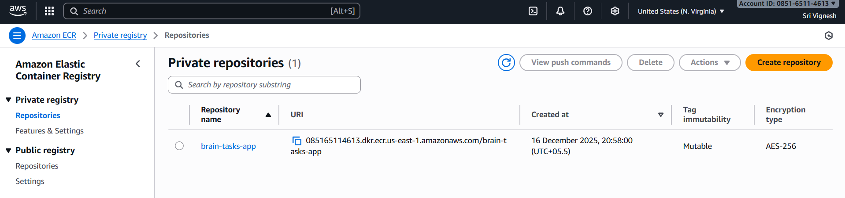

Create EKS Cluster
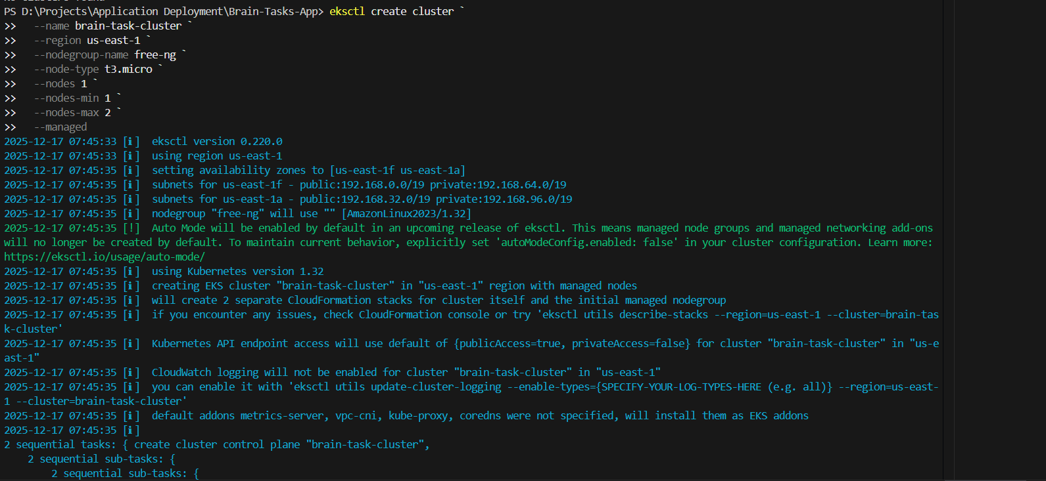

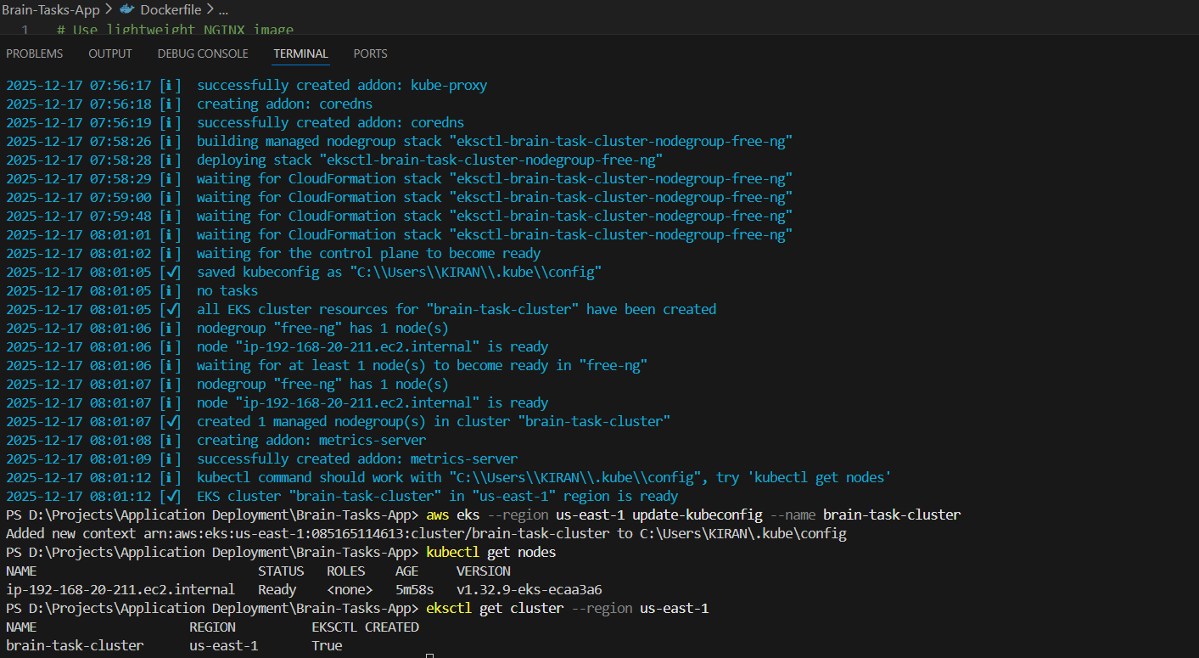
Created EKS Cluster
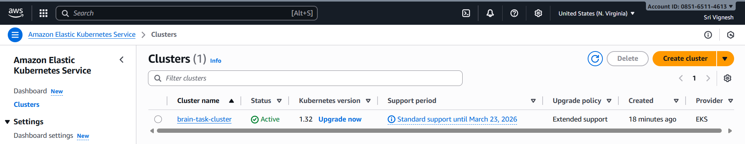

deployment.yaml and service.yaml files are available in the repository

Kubernetees Deploy & Service
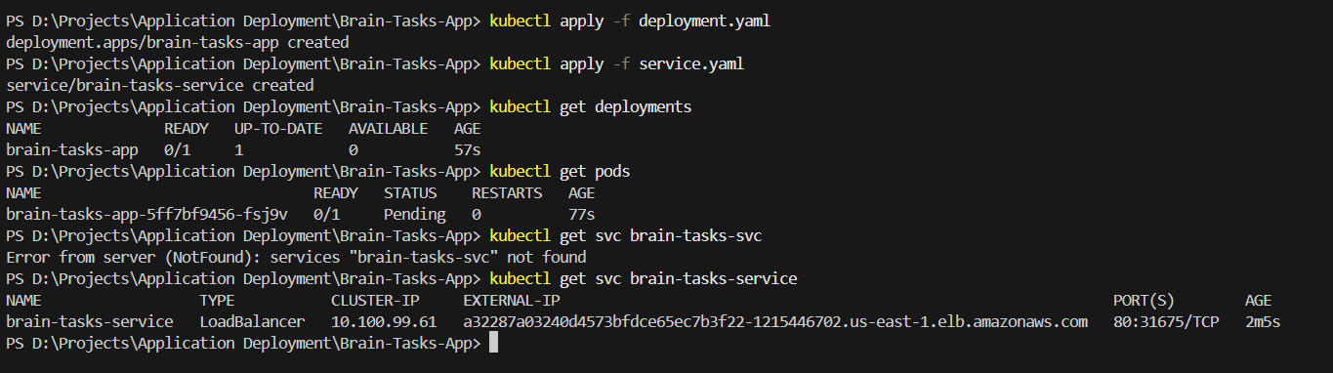
Adding to GitHub
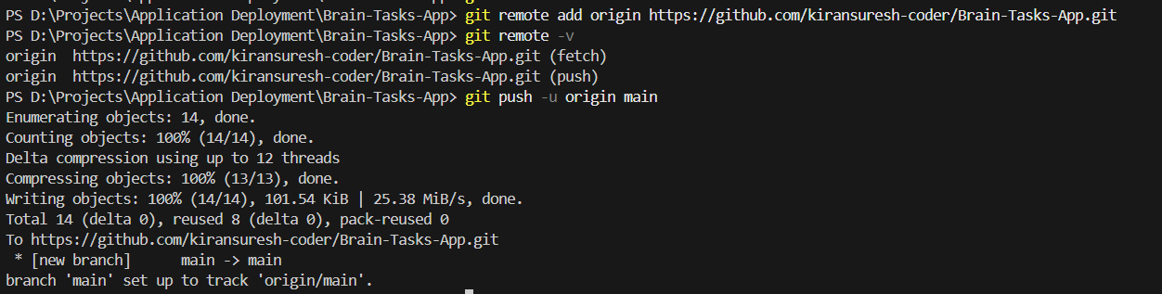
Code-Build
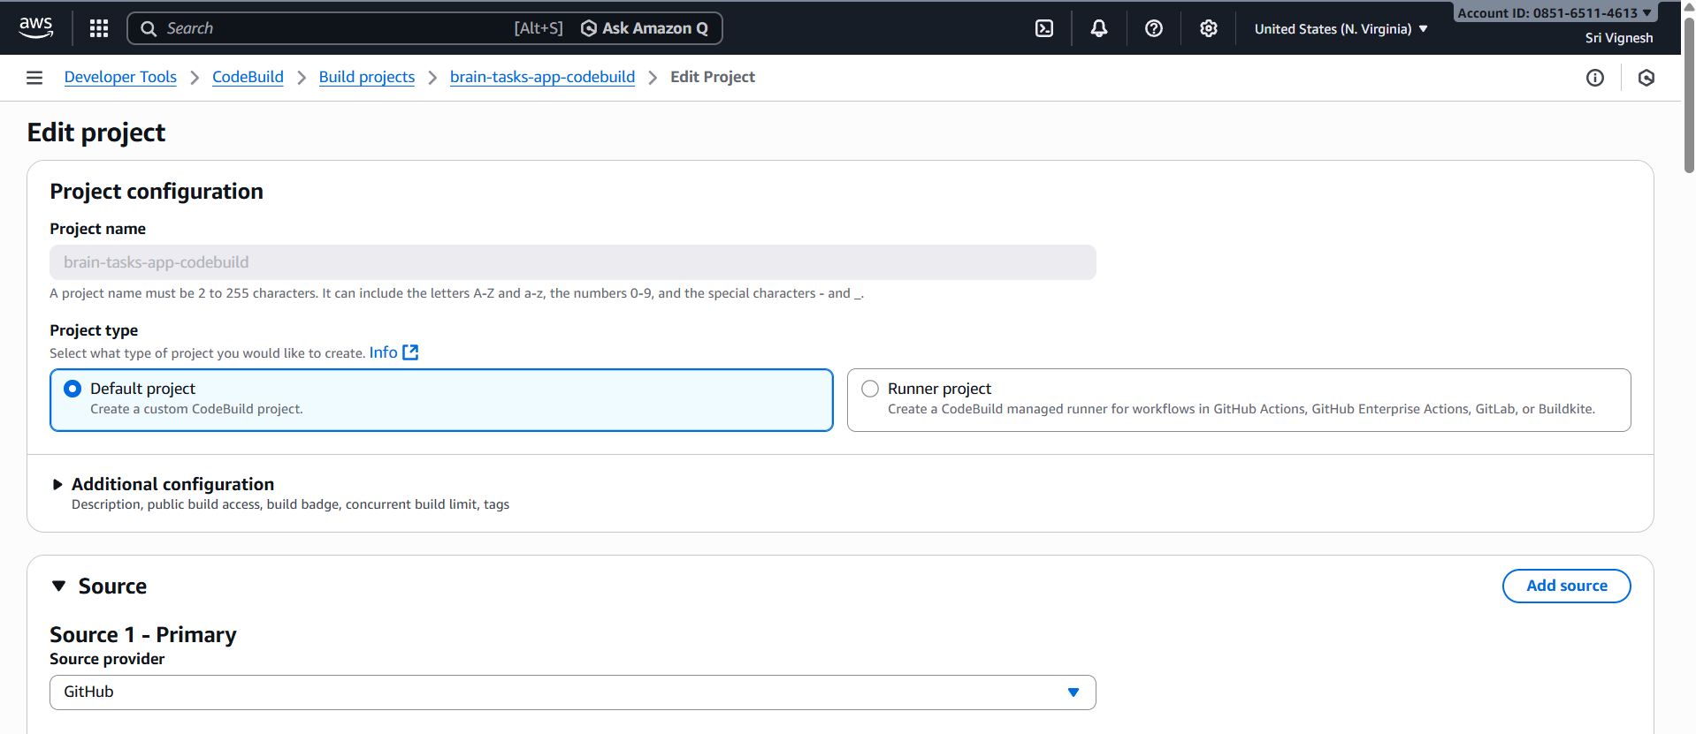
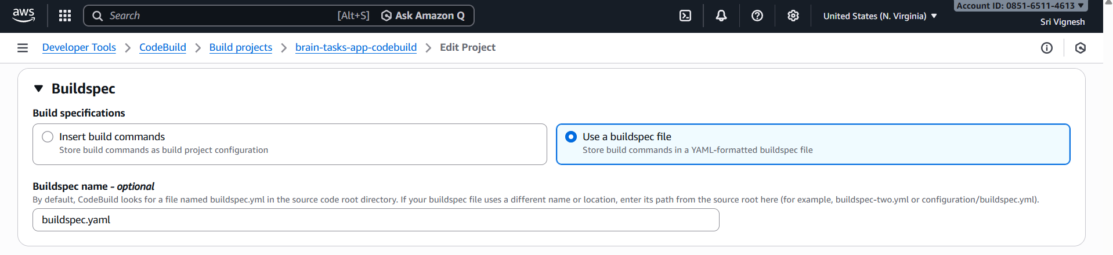

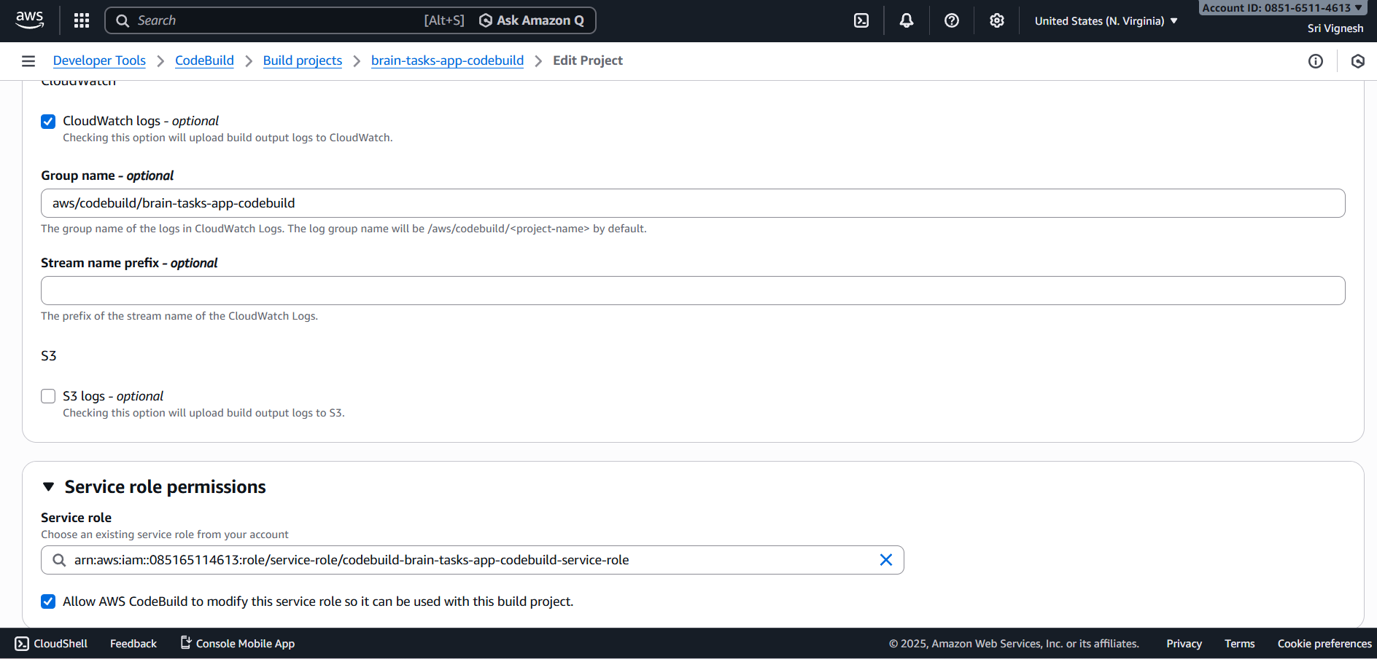
Succeeded code-build
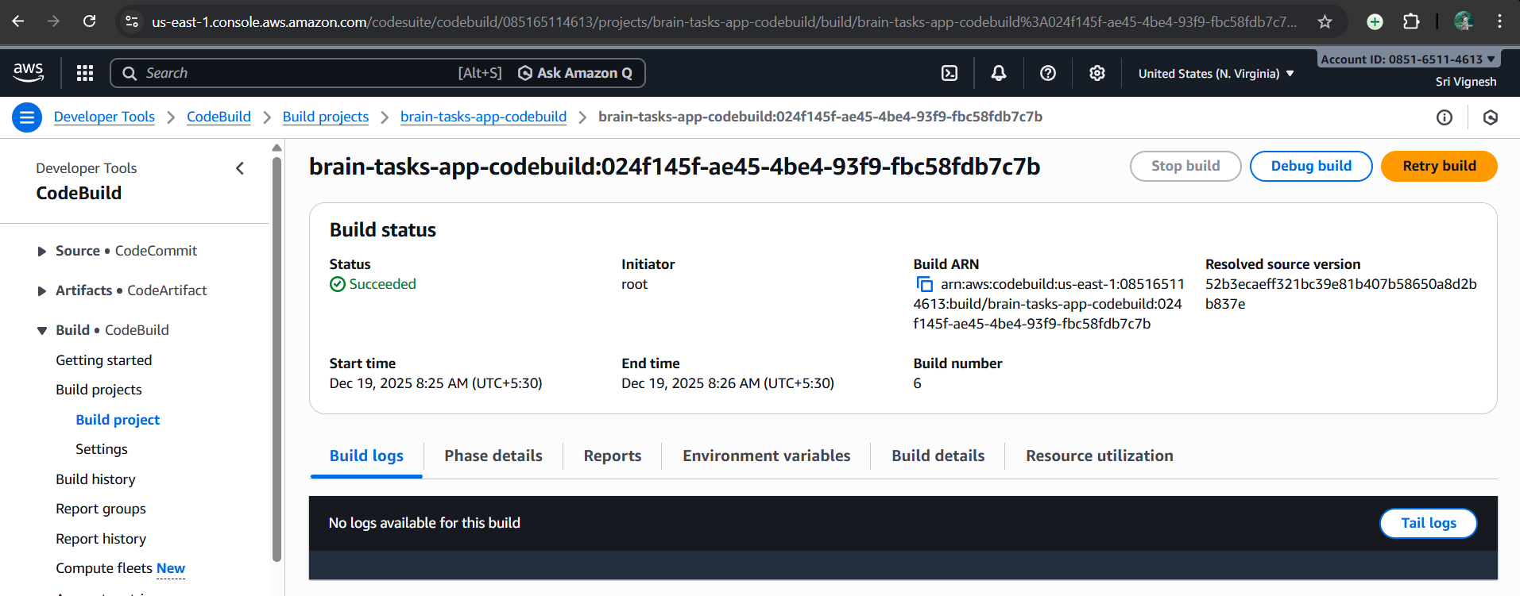

Code Deploy
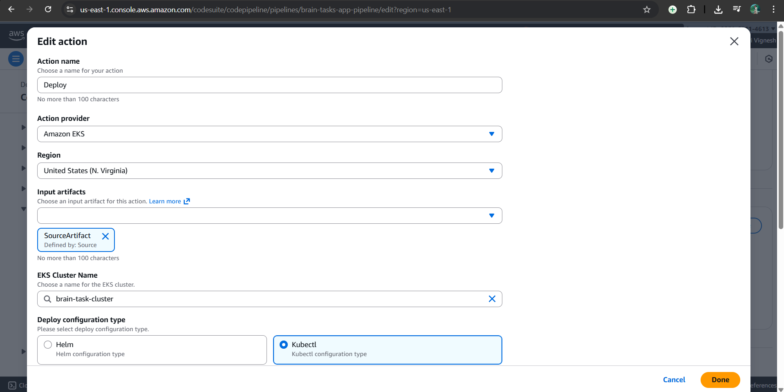

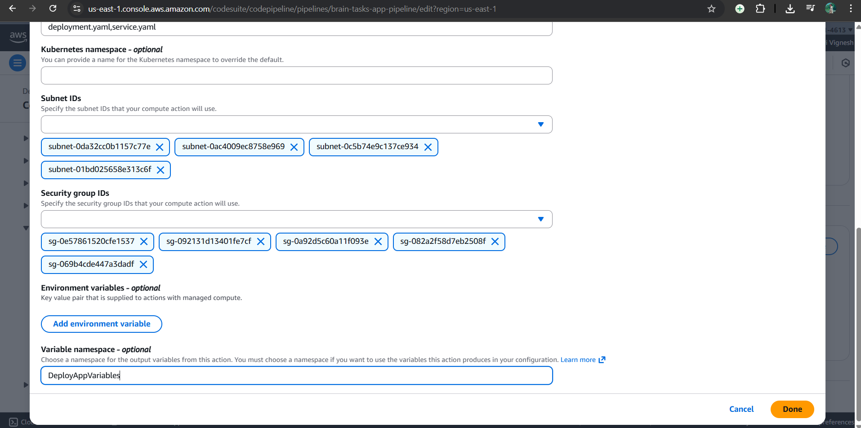
Creating Pipeline
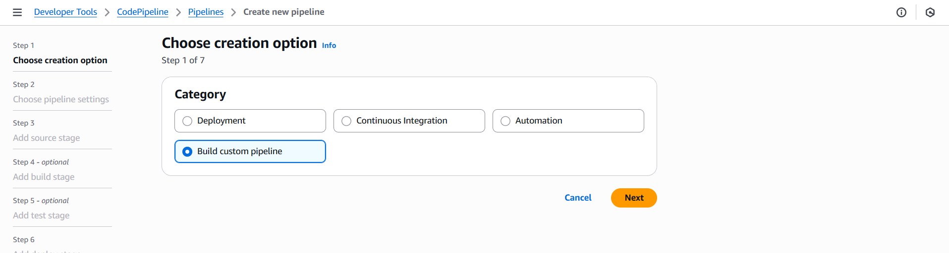
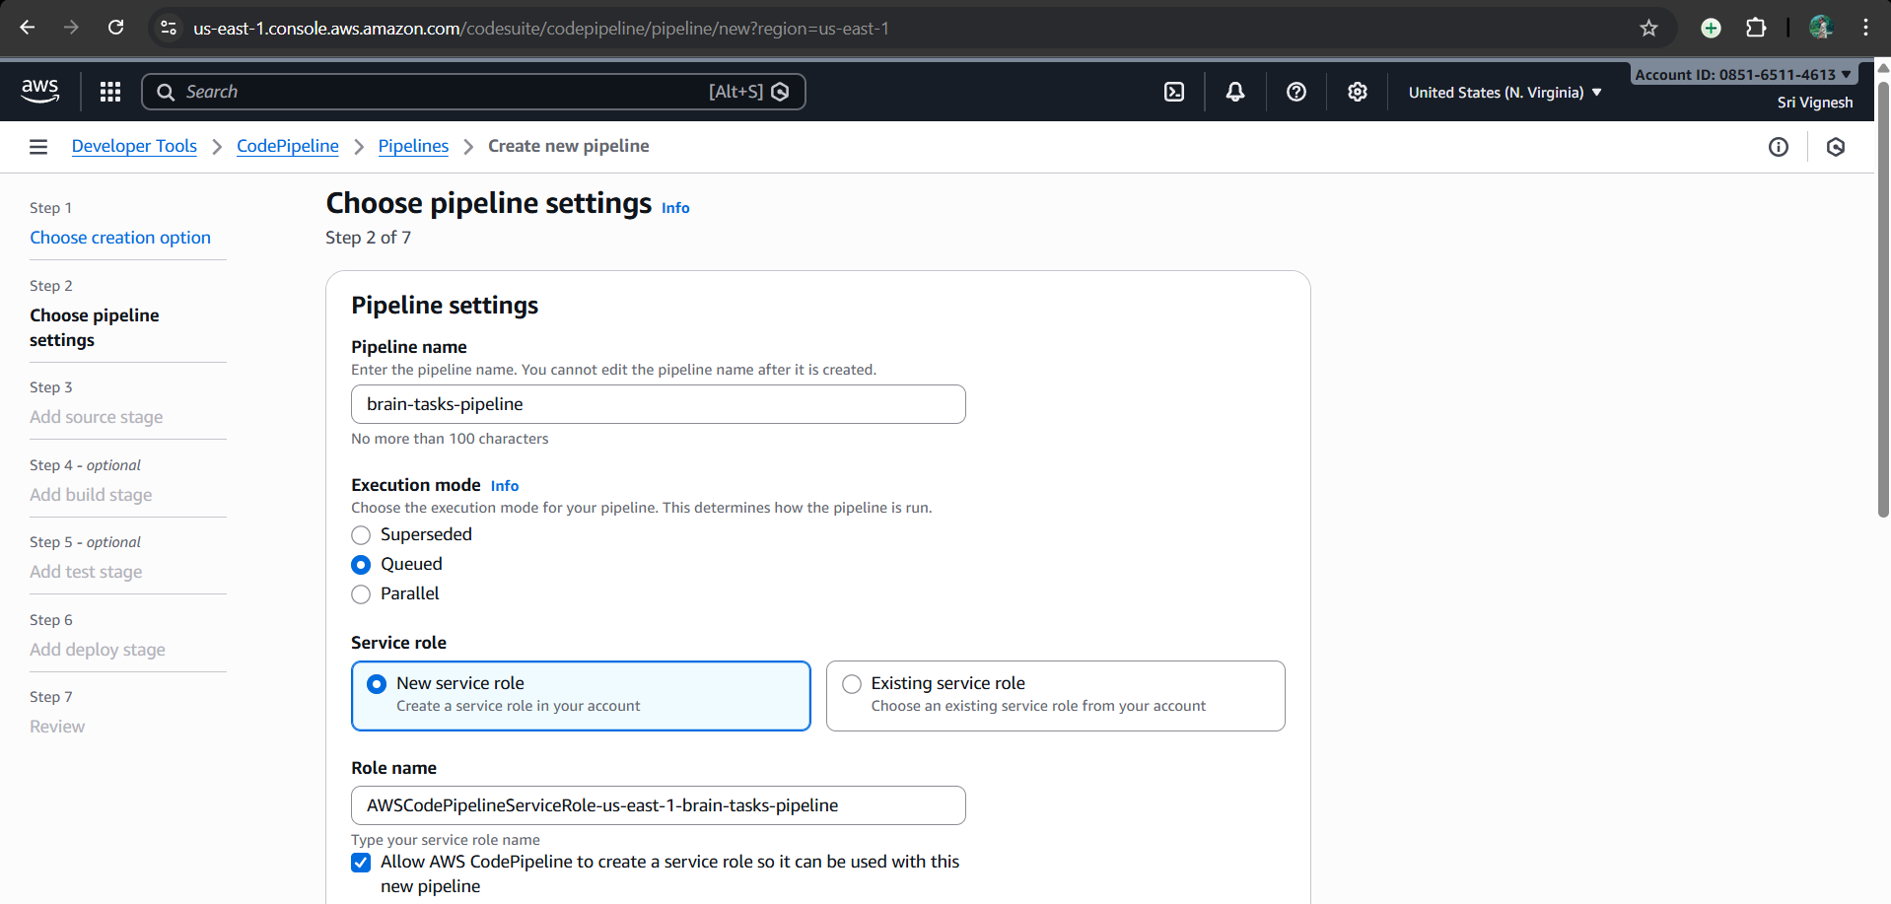

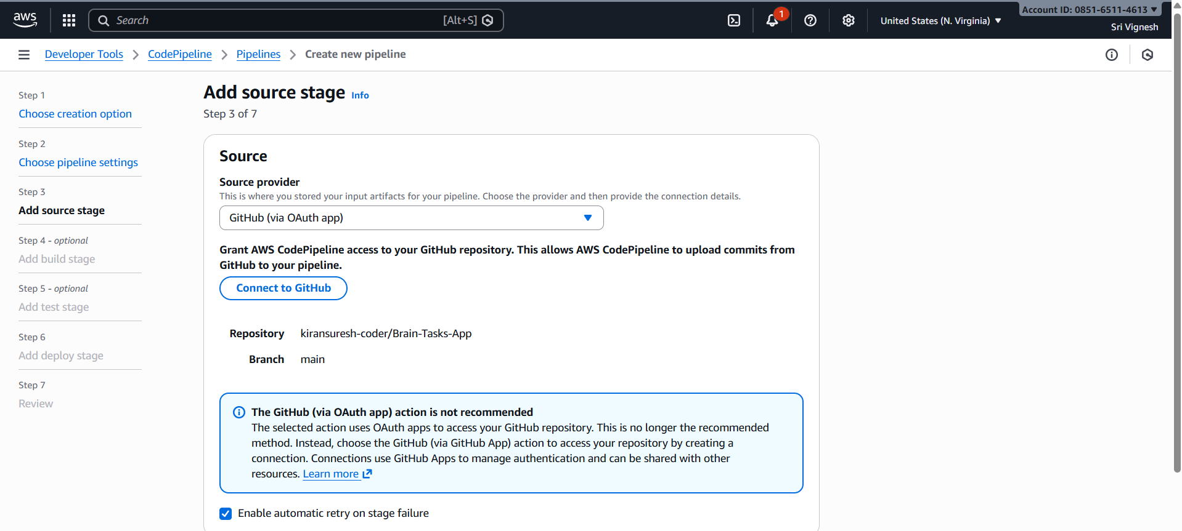

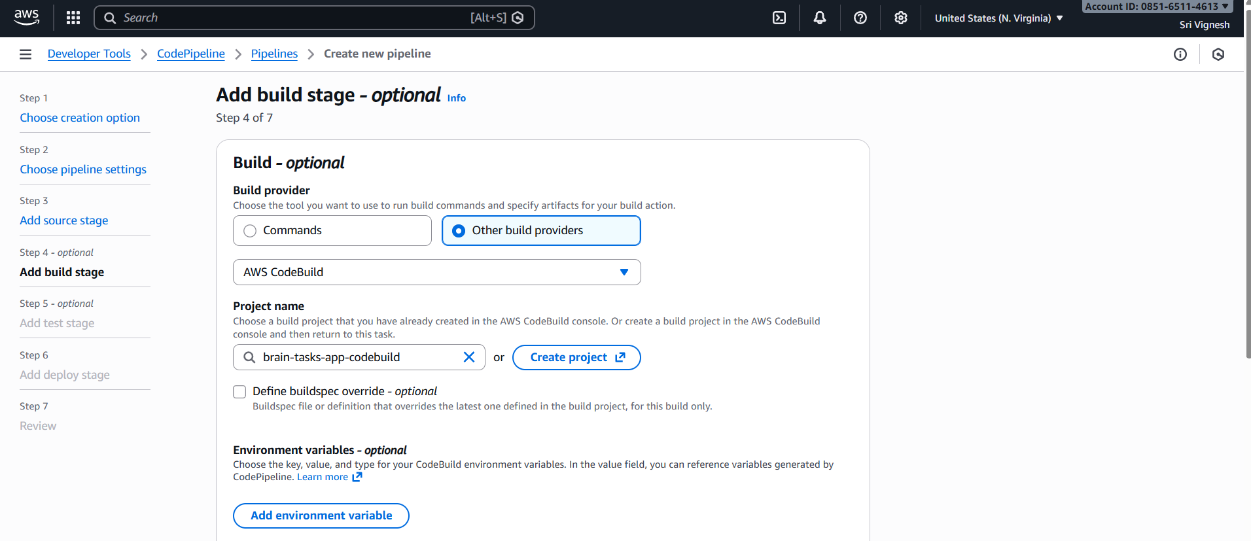
Resolving errorrs: Adding Roles to IAM
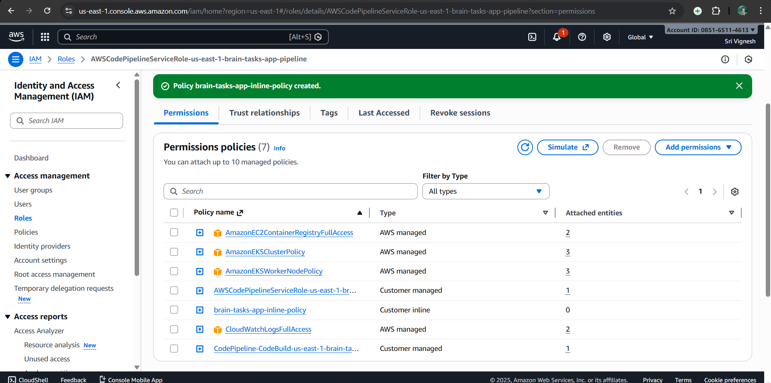
Resolving errorrs: Adding EKS roles
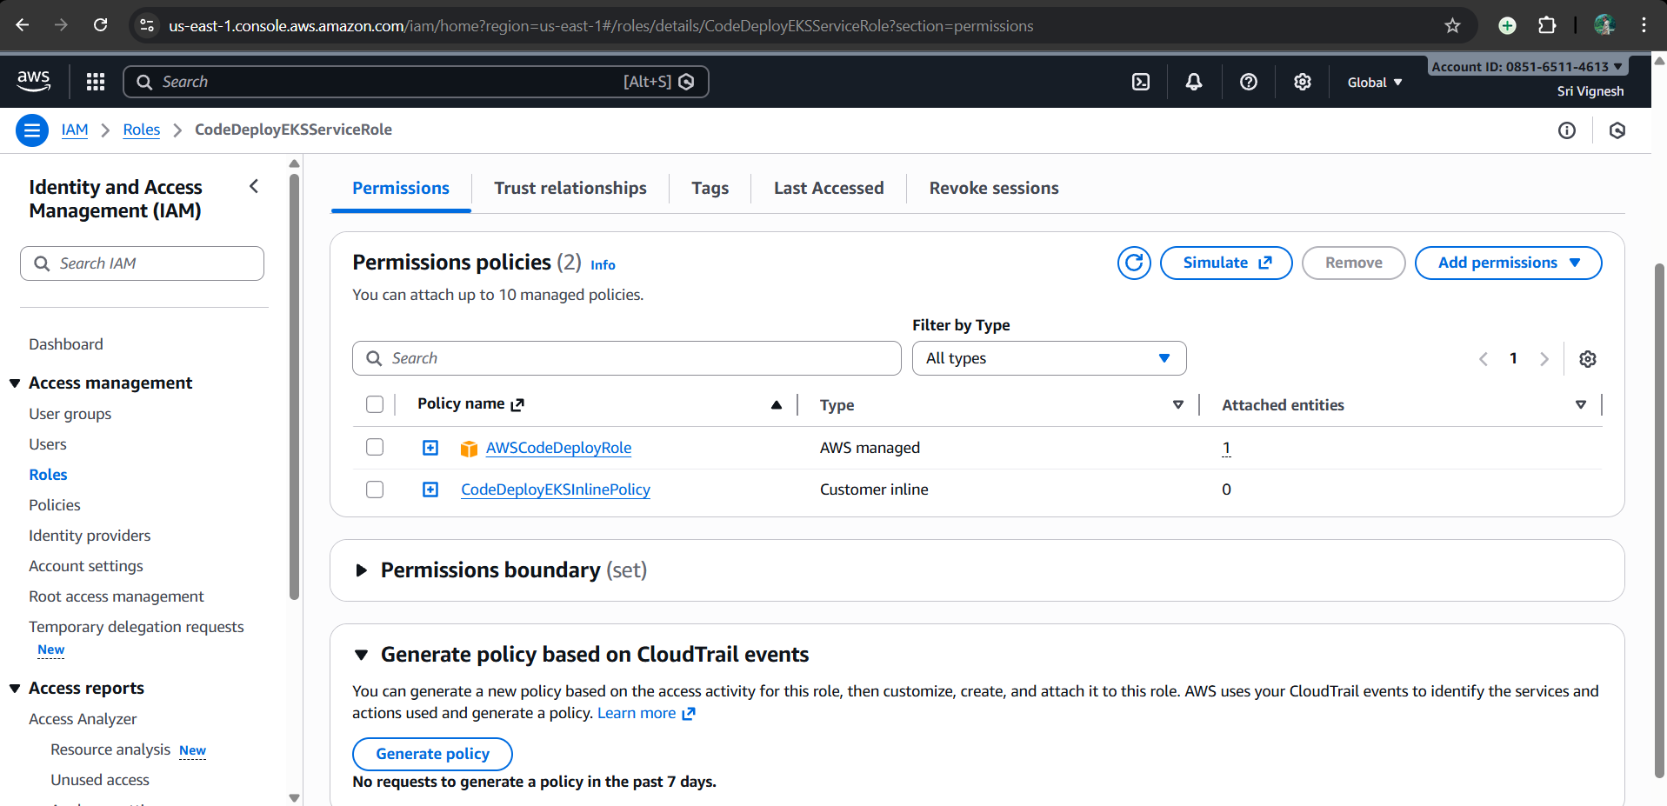

Resolving errorrs: Add the Role to aws-auth ConfigMap
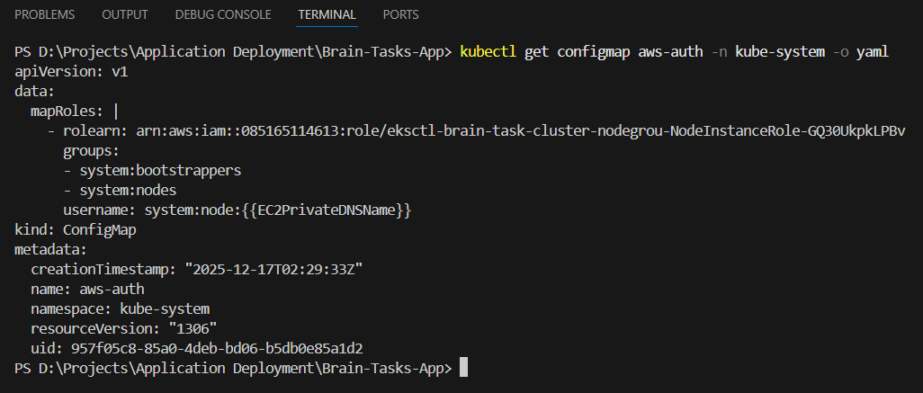

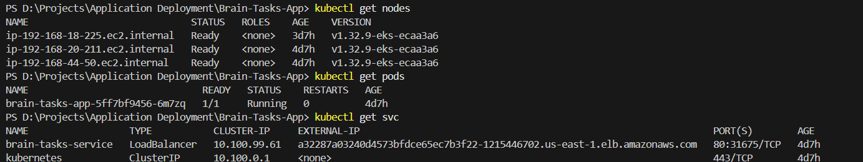
Resolving errorrs : IAM fix by adding policy in build pipeline service role

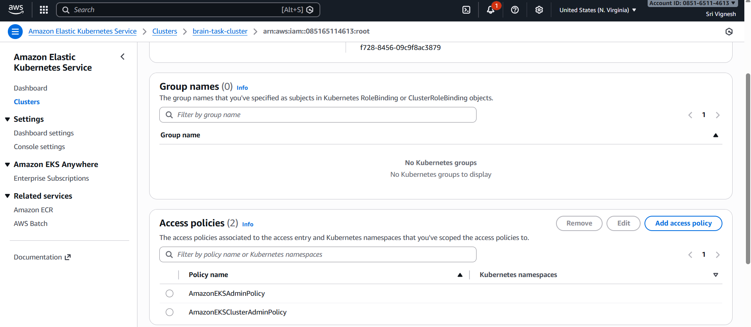
Resolving errorrs : Add this IAM role as an access entry in your EKS cluster to perform kubectl commands
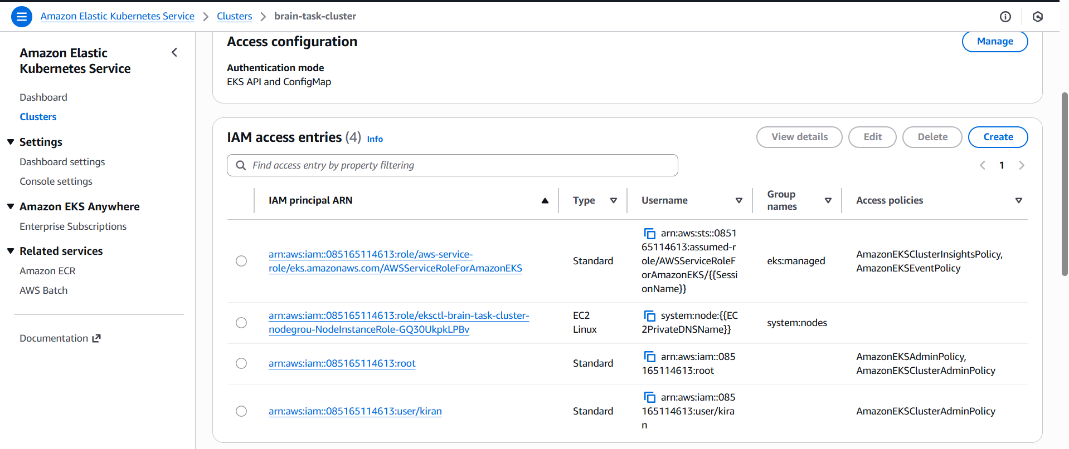

Adding service role to IAM policy.
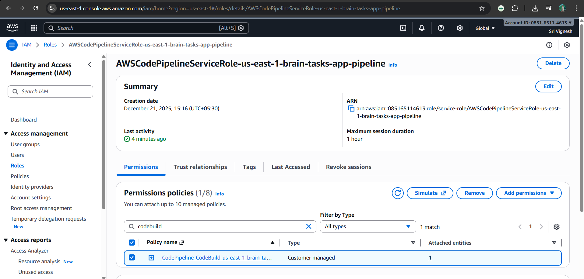
Cloud Watch
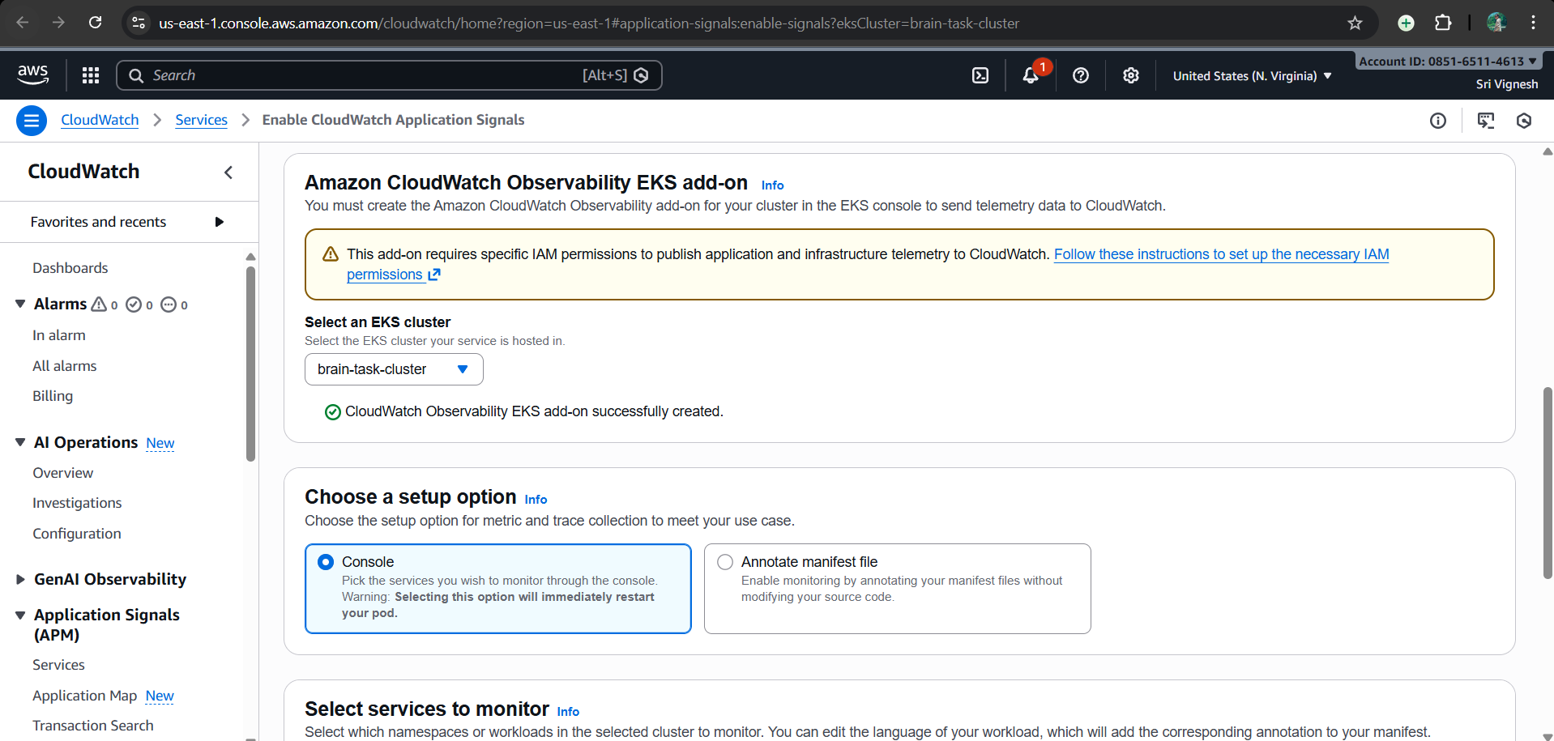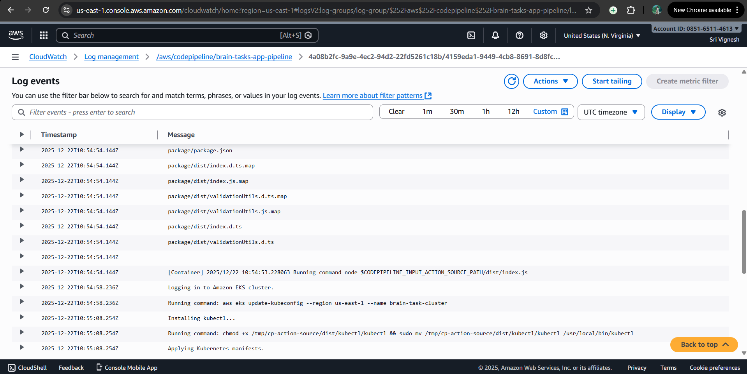
Pipeline
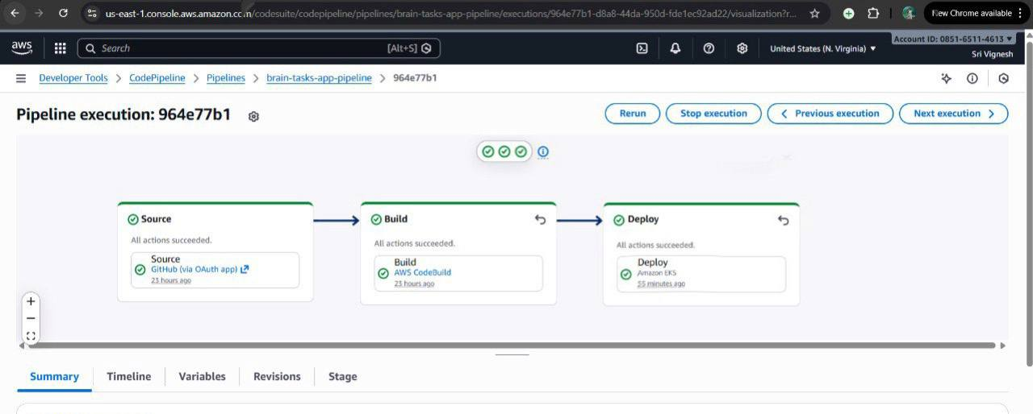
Eks running on port 3000:
